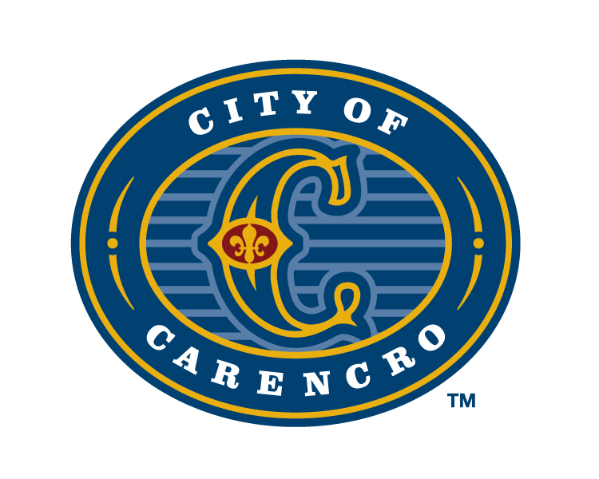
AGENDA
COUNCIL BRIEFING
MONDAY, SEPTEMBER 9, 2024 6:00 PM
CARENCRO CITY HALL
210 E. ST. PETER ST.
CARENCRO, LOUISIANA

A. CALL TO ORDER

B. PLEDGE OF ALLEGIANCE AND MOMENT OF SILENT PRAYER. Councilmember

C. DISCUSSION ITEMS:
Bayou Vermillion District – Stephen Broussard
Temporary Housing & Shelter Assistance Program- Craig Stansbury
Civil Service Appointments- Walter Cain Smith & Todd Olivier
Tractor Trailers Operations- Surface Streets of Carencro
EV Charging Station Grant

D. CAO ANNOUNCEMENTS:

E. PUBLIC COMMENT:

F. ADJOURN:

PLEASE NOTE: THE MEETING CAN BE VIEWED VIA OUR CITY OF CARENCRO WEBSITE: www.carencro.org
CLICK THE LINK TAB “LIVESTREAM” AT THE TOP OF THE PAGE.

“REASONABLE ACCOMMODATIONS WILL BE MADE FOR THE HEARING OR VISUALLY IMPAIRED WISHING TO ATTEND AND PARTICIPATE IN CITY COUNCIL MEETINGS UPON GIVING AT LEAST THREE (3) DAYS PRIOR NOTICE BY CALLING (337) 896-8481.
Posted at City Hall 9/6/24 AT 0900 HOURS

